**CANTEEN AUTOMATION SYSTEM**

**USECASE DIAGRAM :**

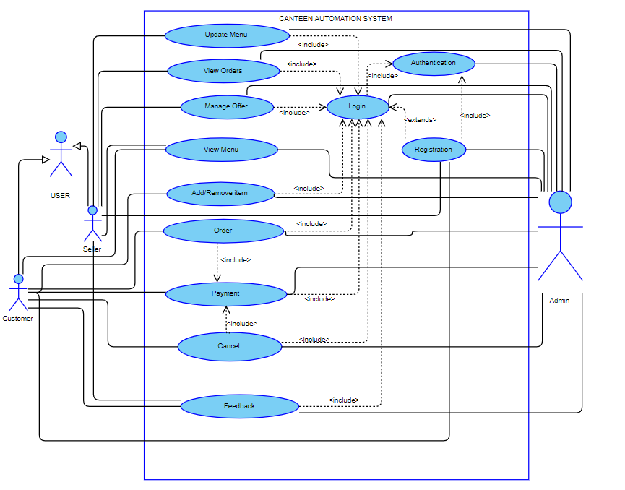

There are two types of user interacting to the System. They are Customer and Seller. They are the primary actor of our system.

**REGISTRATION:**

The usecase registration will be used when a new user will join the canteen automation system. To register on the system there are two types of user namely customer and the seller. In case of registration the user has entered his Name, Phone no., Email-id, and Password. All these data will get stored in the system database. A user-id (i.e. email-id) and password will be used for login.

**LOGIN:**

Login usecase will be used by the existing customer when the user wants to access the system. To login to the system the user has to fill his/her user-id and password. Based on these credential a verification will be done, if the details entered is verified then the user will get access to the system otherwise the access will be denied.

**AUTHENTICATION:**

When a user tries to login or register then their credential will be verified by the admin. In case of login the user id and password verification is done. It is done by verifying the user id and password exist in database or not. In case of registration availability of user id is verified in the database.

**UPDATE MENU**:

This used case will be used by seller to add item or remove item from the menu of canteen. The seller can set the price of the items. The seller can update price of a particular item. The seller can also update or set the quantity of a particular item. He/she can increment /decrement the quantity of the particular item. The system will also update the quantity of the items based on the sale of the item.

**MANAGE OFFERS:**

The usecase add offer will be used by seller only. Seller can any time add offer, make combos, or can give discount on any particular item. Offer will be automatically applied to the menu and no promo code will be required from the user.

**VIEW ORDER:**

The usecase view order will be used by seller only. The seller can see the upcoming orders, past order and print receipt for the orders.

**VIEW MENU:**

This usecase can be used by both the customer as well as the seller. This is used to view the menu of canteen along with price of that item. This functionality can be used without login to the system.

**ADD/REMOVE ITEMS:**

This functionality is used by the customer to select a particular item from the menu of canteen and also allow to deselect any selected items. It enables the user to Add the selected item to the cart.

**ORDER:** This functionality will be used by customer to place order. The items in the cart are ordered using this functionality.

**PAYMENT:** This functionality will be used by customer for making Payment. Payment is compulsory for placing any order.

**CANCEL:** This is enable the user to cancel the order. In case of successful cancellation refund will be done.

**ASSUMPTIONS:**

1. There are two types of user using the system. They are Customer and the Seller.

2. To use any function of the system the user must have to login in the system.

3. Admin is a secondary actor which acts as the manager of the System. It mains the coordination among different functionalities of the system. It accept/reject order based on the availability of the product/item.

4. There will be an authentication system for login and registration based on some data such as user-id, email id, and password.

5. Payment will be done using upi/cash.

6. Offer will be automatically applied in the order. No promocode or inclusion of offer is required from the customer end.

7. Modification of Order ones placed is not possible.

**By** : Group 9( Jyoti Kumari, Manohar Kumar Verma, Ayush Verma)